CASE STUDY SUBMISSION · FORWARD DEPLOYED ENGINEER (INTERN TO FTE)
Improving MoveInSync Play Store Ratings
Evidence-based product and engineering recommendations
Prepared by | Bukke Giridhar Naik
Prepared for | MoveInSync CTO, Product Head and Engineering team
Date | 11 October 2026
Data | Public Google Play listing for MoveInSync: Enabling Hybrid Workplaces,
captured 8 October 2026

1. Executive summary

The Play Store shows MoveInSync at 4.6 stars, about 1.15 lakh reviews and more than 10 lakh downloads (page captured 8 October 2026). I read a sample of roughly 560 public reviews, written between 2018 and September 2026, to understand why employees are unhappy enough to write them.
My short answer is that people are not complaining about the idea of the app. They are complaining that it lets them down at the one moment they need it: they are standing at the pickup point, the cab is nearby, and the app shows a stale location, a blank screen, an OTP that never arrives, or a login screen. About two thirds of the reviews in my sample are negative, and the sample is certainly tilted negative compared with the full 1.15 lakh, so I do not read that as the true split. What I trust is the ranking of complaints and how often the same complaint comes back.
The biggest problems, roughly in order of how often they appear
- Live tracking and ETA cannot be trusted. Frozen cab icons, an ETA that jumps from 5 to 30 minutes, locations that are an hour old, and a map that zooms itself out. Around 30% of reviews touch this. The map zoom problem was acknowledged in public replies in 2019, 2024 and 2025 and is still being reported.
- The app will not open, or will not let people in. About a dozen reviews from June to September 2026 describe an "app not installed from Play Store" error, usually after an auto-update, fixed only by reinstalling. On top of that, OTPs that never arrive (some people say days of retries) and forced logouts that also lock people out of the SOS button.
- Booking and scheduling logic. Bookings that fail, disappear, duplicate or land on the wrong date, and nothing for hybrid workers who want Monday, Wednesday and Friday only.
- "No Show" marks that people feel are unfair. Few reviews, but the most angry ones, and some mention salary deductions.
- No way to message the driver, notification and pop-up overload, forced feedback screens, and a transport policy that has to be accepted every time the app opens.
What I would do first. Treat the launch and login failures as incidents and fix them before anything else, because they produce one-star reviews that no design polish can offset. Then make tracking honest (show how old the location is, stop the auto zoom), cut the interruptions, and fix how No Show is decided. In parallel, build a small automated pipeline that reads new reviews, classifies them, spots spikes by app version and routes them to the right team, so the question "how are our ratings?" is answered by a dashboard and a weekly note instead of a one-off study.
What to expect. The lifetime average moves slowly. With about 115,000 ratings already at 4.6, getting to 4.7 would take roughly 57,500 new ratings averaging 4.9. So I would manage to the rolling 30 and 90 day rating and the share of one-star reviews, and I would measure both from week zero. I have not put a number on the expected improvement because I do not have the star histogram or crash data to support one.

2. Assignment objective

MoveInSync sells a simple promise: the employee books a ride, the system plans it, and the phone tells them truthfully where the cab is and when to walk out. The Play Store rating is the public scorecard of whether that promise holds at the moment of use.
It matters here for a few reasons that go beyond installs.
- Most users do not choose the app. Their employer requires it, and several reviewers say so ("I have no other option"). The rating therefore does less for downloads than in a consumer app, but it is read by the transport heads and procurement teams of 430+ customers. One reviewer addresses "the companies who hire MoveInSync" directly.
- Reviews behave like an unfiltered ticket queue. Many people say they tried email, the helpdesk and the in-app bug report first, got nothing back, and ended up on the Play Store.
- A bad app moment turns into real cost: a helpdesk call, a No Show dispute, a missed shift, and a customer who starts asking whether the tool is worth keeping.
- Some reviewers write that the 4.6 "can't be genuine". A gap between the visible rating and the lived experience is a reputation problem on its own.

3. Research methodology

Data. I used the public Google Play listing for MoveInSync, captured as page text on 8 October 2026: rating, review count, downloads, each review with date, text and helpful votes, and the developer's public replies. The captured text has no star value per review and no star histogram, which limits what I can say (see section 15).
Steps.
- Cleaned the text. The first three reviews appeared twice, so I removed duplicates and separated developer replies from reviews.
- Read every review and tagged it with one or more categories from a fixed list (section 5), a sentiment (positive, mixed, negative) and an owner: product or engineering, customer-configured, or operations. The owner tag comes from the developer replies, which repeatedly say that cut-off times, OTP frequency, the passenger list and calling are set per organisation.
- Counted mentions per category. A review can count in several categories. Counts are done by hand, rounded to the nearest 5 and probably off by about 20%, so use them to rank, not to quote.
- Split the reviews into four periods (2018-19, 2020-23, 2024-25, 2026) to separate problems that never went away from problems that are new.
- Ranked each issue on customer impact, frequency, business impact and rough engineering effort. Anything that blocks the core journey or touches safety ranks above an annoyance, whatever the count.
Assumptions I am making.
- The Play page shows a "most relevant" slice, so the sample leans negative. I do not extrapolate sentiment to all 1.15 lakh reviews.
- "Lower than it should be" means the recent trend and tone look worse than the 4.6 suggests. I could not check the rolling rating.
- Reviewers sometimes blame the app for things the vendor or employer controls. The owner tag is my way of handling that.
- Effort sizes assume a small team: S is up to two weeks, M is two to six weeks, L is more.

4. Dataset overview

Item | Value
Rating on the store page | 4.6
Item | Value
Review volume | about 1.15 lakh
Downloads | 10 lakh+
Last update shown | 8 Oct 2026
Reviews analysed | about 560 (my count, approximate)
Time range | 2018 to 17 Sep 2026
Share dated Apr to Sep 2026 | about 40% (estimate)
Positive / mixed / negative | about 22% / 13% / 65% (estimate from text)
Reviews with a developer reply | about 35% overall, almost none in 2026
Store data-safety notes | No data shared with third parties; collects location and personal info; "data can't be deleted"

5. Review analysis

For each category I give a summary, a few representative reviews, what the pain is, what it means for engineering and the business, and a priority. I name reviewers and dates so you can find the originals.
"Owner" is P for product/engineering, C for customer-configured and O for operations.

5.1 App will not open, crashes, "not installed from Play Store" (P0, owner P)
People report a blank screen, an app that closes after a second, or an error saying it was not installed from the Play Store, and the only fix is to uninstall and reinstall. Examples: Govindaraj K (30 Jul 2026), Pratik Gadge (9 Aug), Aakash Kumar (6 Aug: "after 48 hours it shows an error"), Sheetal Sorout, kurakula dayakar, Vishal Gomes, Santosh Kumar Pal, and Ayan Bhattacharya (10 Aug), who says the app works until it auto-updates. There are also device-specific reports for Android 14, Android 17, OnePlus 13 and Pixel 6a.
There is a precedent. In 2023 a user on an unrooted Pixel 7 was blocked by a "does not work on rooted device" message, fixed in v11.4.7. My guess is that an installer or integrity check is misfiring, which I treat as a hypothesis until the vitals data confirms it. The pain is plain: cab number, OTP and driver details are unreachable while the cab is waiting. This is the largest new source of one-star reviews.

5.2 Login, OTP and sessions (P0, owner P and C)
OTPs do not arrive by SMS, WhatsApp or email: Dhiraj Nathani (9 Sep 2026), Manuel Lacanlale, Saurabh S., Himanshi Jeenwal, Goli Nagamalleswararao ("nearly 50 times"), Innocentia Dike ("7 days"). Naveen Kumar adds that the app never says whether his number is even registered. On some OS versions the OTP box does not appear (shailesh pal, Android 14). Separately, many people are logged out every few minutes or on every open (Rayan D'Souza, Kalyan, Pranay Asadhi, Paras Domadiya, Samudrala Dheeraj, Parimal Jain).
The safety angle matters most. Rayan points out that women who want to send an SOS can be logged out first and have to sign in again through the company app. Developer replies say OTP login is a customer security requirement, which explains why OTPs are frequent. It does not explain OTPs that never arrive, and it does not explain why the same device is not remembered.

5.3 GPS and live tracking (P0 and P1, owner P with O)
Tracking is the most-mentioned complaint and also the most-praised feature ("tracking is excellent and accurate" appears often in 2026). That split suggests quality varies by customer, device, network or driver app, not that tracking is broken everywhere. Finding what separates the good cohort from the bad one is probably the most useful single analysis the team can do.
Complaints: the cab icon stuck for 10 to 30 minutes (Garima Deswal, Shaik Arshad), a location labelled "one or two hours ago" (SWASTIK TRIPATHI, Aug 2026), a cab that "suddenly shows up at your location" (Lettinthang Haokip), and a pickup pin that differs from what the driver receives (Savitha Sathyan, Thippesh Km).
The map auto zoom-out is the clearest example of a defect that never got fixed. Users report the map re-framing itself seconds after they zoom in. It appears in 2019, 2024 (Rohit Mukherjee, vatsal shah,
Jinen Konjengcha), November 2025 (Vinayak Phal) and 2026, and the developer acknowledged it in 2019, January 2024 and November 2025.

5.4 ETA and pickup time (P1, owner P and O)
The ETA swings (Manasa H: 5 minutes becomes 30; John Smith, 13 Jun 2026: the app says an hour, the driver arrives in five). Shaik Arshad asks the company to stop showing ETAs if they cannot be accurate. The planned pickup time also moves from day to day for the same cab-mates (Nitin Pandey, utkarsh lath, Vijay Thadkal, who says same-spot pickups are scheduled 1 to 10 minutes apart).

5.5 Booking and scheduling (P1, owner P with C)
Bookings fail when many people book at once (Manoj Kumar S, Joem LZD, Raviraj P), do not appear in the list although the travel desk confirms them (Rahul menon, TheProperDog101), end up on different dates than chosen (Nontsikelelo Candice, 18 Jun 2026), or default to the wrong day (Pratyusha Ghosh, 11 May 2026, a Sunday booking jumped to Tuesday). Waitlisted passengers cannot cancel or rebook
(Senyorita, Lalaine, Nath Nath). Hybrid workers ask for non-consecutive dates (TAMAL MAJUMDER, Shaun, Ankush Comm). After a redesign, shuttle booking became a two-step flow and one user thought he had booked a cab when he had not (Lakshya Bang, 7 Jul 2026).

5.6 UI and UX (P1 and P2, owner P)
Complaints include lost colour coding, a tiny calendar, "Login and Logout" shown in different orders on different screens (Pavan Yoboy says this leads to No Shows), many taps before the main page, and poor first-time guidance (brock singh, Apr 2026). Opinions on the 2026 redesign are split: some reviews call it simple and clear, others "modern but not simple". Lakshya's real complaint is how changes were released, not the design itself.

5.7 Performance and startup (P1, owner P)
Loads of 10 to 20 seconds (Kanthala Raghu), a splash animation, full-screen banners (Ankit Rathi: an "earth month" banner before he can see his cab), and a transport policy "I agree" screen on every open (P Dilip Kumar, Dileep Nelli, Yuvaraj D who says he has accepted it "more than 500 times", Pradyumna Kammardi, Sourabh Panse). Heavy battery use is also mentioned.

5.8 Network and offline (P1, owner P)
Some users get "no network" on a good connection. It works on Wi-Fi but not mobile data (suraj kumar, Sep 2026) or the other way round (Roxal Nirwan; shashank rana on Airtel Wi-Fi). The same pattern shows up in 2022, 2024 and 2026, so it recurs. Sailesh Sunkara (Jan 2026) lost the OTP and driver details when signal dropped at the gate, and Karthik Mohan and Deepak Sonar describe basement pickups with no coverage. A developer once replied that tracking cannot work offline, which is true, but static trip details such as cab number, driver and OTP can be cached.

5.9 Notifications and pop-ups (P1 and P2, owner P)
Too many: "Cancel login and avoid being a no show" about ten times a day (Akash Balaji), delay popups every few minutes (Prateek Goyal), notifications after the trip is over (Tushar Gaur), and a Play Store review prompt after every ride (Antony Peter). Swapnil Deore says pop-ups that will not close block even the SOS button. Others say notifications are late, wrong or missing (Muthusamy A, Anshul Rawat). Tushar Chib objects to being forced to enable notifications.

5.10 Driver communication (P1, owner P and C)
This is the request that spans the most years. Calls are blocked by company policy (Prasanna, Jul 2025), calls drop after one ring or have bad audio (Anuj Jain), and drivers say they cannot reach passengers (Rahul Saini). People ask for chat or quick messages: Pakhi Mehra (37 helpful votes), Abhishek Chaudhary (221 helpful votes, 2022), Caleb Sam, Gaurav Garg, Akshay Varshney, and Deepak Sonar, who wants the driver to be able to say which pillar he is at in a basement. A 2022 developer reply said driver chat was "something we are working on".
Two reviewers (kanchan kumar, Aug 2026; shahid raza, 2024) object that the app forces microphone permission although calls go through the normal dialer. A chat or quick-message feature would not need the microphone at all.

5.11 Pickup experience and No Show (P0 and P1, owner P and O)
A No Show is not a small thing: some reviewers mention fees taken from their salary. People describe being marked No Show when the app showed the wrong location (shivam pande), the ETA was wrong
(John Smith), the time changed without notice (Jay, Oct 2025), the driver never arrived (Devyash Pundir, 21 Jul 2026: waited more than two hours), or after a successful QR boarding (kanishk aggarwal, Rakesh Rao Aroor). Others ask for a call before a night-time No Show for women (Dishika Anthoney) and a button to say "I'm not travelling" so the driver does not wait (Thameem Ansari, Prashant Kale).

5.12 Routing and clubbing (P1 and P2, owner O with the P engine)
Long detours and odd clubbing: 1.5 hours before shift for a 10-minute ride (shubham kumar), 2.5 hours home against 50 minutes (banoori bharath reddy, Diwesh Sharma), and same-building passengers scheduled five minutes apart so that early riders wait in the cab (utkarsh lath). Earlier replies say routing follows the customer's policy. Whether or not that is true, the product could show detour metrics and flag outliers to the customer.

5.13 Support and helpdesk (P1, owner O)
The helpdesk line is always busy or cuts off (Rishab Verma, suraj tiwari, Anubhav Paliwal), some agents are called rude, and there is no way to see whether a request raised in the app was received (Amritha Sundar, Suman Das). Some emails go unanswered (Sanjna Nair; Deepak Kushwaha asks "do you even read the comments?"). Most older developer replies end with "write to app@moveinsync.com", often with "contact your transport facility manager" added, and reviewers read that as brushing them off. Almost none of the 2026 reviews have a reply.

5.14 Co-passenger information (P2, owner C and P)
People want to know who else is in the cab and in what pickup order (Khan Najib, Kishor Kumar, heena gandhi, Badhrish Srinivasan). Replies say the organisation has switched the passenger list off. What is missing is a clear message in the app saying so, and a privacy-safe default such as initials, area and pickup order.

5.15 Safety (P0 as an enabler)
SOS and OTP boarding are valued (Sumudu Madushanka, Syed Quadri). The negatives are SOS that needs a login (Rayan), SOS pressed by accident while scrolling (Sudharshaun, 2024), pop-ups covering it (Swapnil), a seat-belt prompt drivers can tick for you (Mehadi Abbas), crowded rear seats and a 12-seater sent for three people (Hussain Sarangpurwala, Marilynn Kalure), and rude drivers (Farhaz Watson).

5.16 Permissions (P2, owner P)
Location is demanded even to scan a QR code (prasanna rao, Arpit Sharma), microphone is demanded without in-app calling, and a few users say they are forced to enable automatic time zone (King Jr, Deejay Deej). Few reviews, but cheap to fix, and the store listing says data cannot be deleted, so trust is already thin.

5.17 Rating and feedback flow (P1, owner P and C)
Trip feedback is forced, cannot be skipped and sometimes appears twice for the same trip (MD, Guru B, Alamin Abdul Raheem, Jigar Gala, jollie anne). The feedback box blocks keyboard suggestions. In other organisations feedback is switched off and users cannot report a bad driver at all (Nitin Garg).
One claim needs checking quickly. Ranveer Mendigire (16 Jul 2026) says the in-app rating only offers 4 or 5 stars, and Neha and Riddhi Gupta write "don't believe the high ratings". I have only this one description, so it is a hypothesis. If it is true, it conflicts with Google's guidance on ratings and it undermines the 4.6.

5.18 Everything else
Desk and parking booking appears in about 3% of reviews (Deepak Kushwaha, Vandana Dhanak,
Prashant Joseph). Reviewers name competitors: Uber, Ola, Rapido, Routematic and EFMFM. About 22% of the sample is positive: easy booking, "real-time tracking is the USP", no ads, polite drivers, SOS, WhatsApp OTP.

6. Complaint frequency analysis

Counts are my approximate mentions out of about 560 reviews, rounded to the nearest 5 and likely off by about 20%. A review can appear in more than one row.
Rank | Category | Mentions | Share | Owner | Blocks core journey?
1 | Live tracking / GPS accuracy | 110 | 20% | P, O | Partly
2 | Booking and scheduling | 85 | 15% | P, C | Yes
3 | Will not open / crash / installer error | 85 | 15% | P | Yes
4 | ETA and pickup time | 70 | 12% | P, O | Partly
5 | Login / OTP / forced logout | 70 | 12% | P, C | Yes
6 | UI/UX confusion | 70 | 12% | P | Partly
7 | Driver communication | 60 | 11% | P, C | Partly
8 | Slow load / performance | 50 | 9% | P | Partly
9 | Routing and clubbing | 45 | 8% | O | No
10 | Helpdesk and support | 40 | 7% | O | No
11 | Notifications | 35 | 6% | P | No
12 | No Show disputes | 30 | 5% | P, O | Partly
13 | Co-passenger information | 25 | 4% | C | No
14 | Forced or duplicate feedback | 25 | 4% | P, C | Yes (blocks screen)
15 | Network / offline | 20 | 4% | P | Yes
16 | Driver behaviour and vehicles | 20 | 4% | O | No
17 | Safety concerns | 15 | 3% | P, O | Yes (SOS)
18 | Policy pop-up on every open | 12 | 2% | P | No
Rank | Category | Mentions | Share | Owner | Blocks core journey?
19 | Permissions | 10 | 2% | P | No
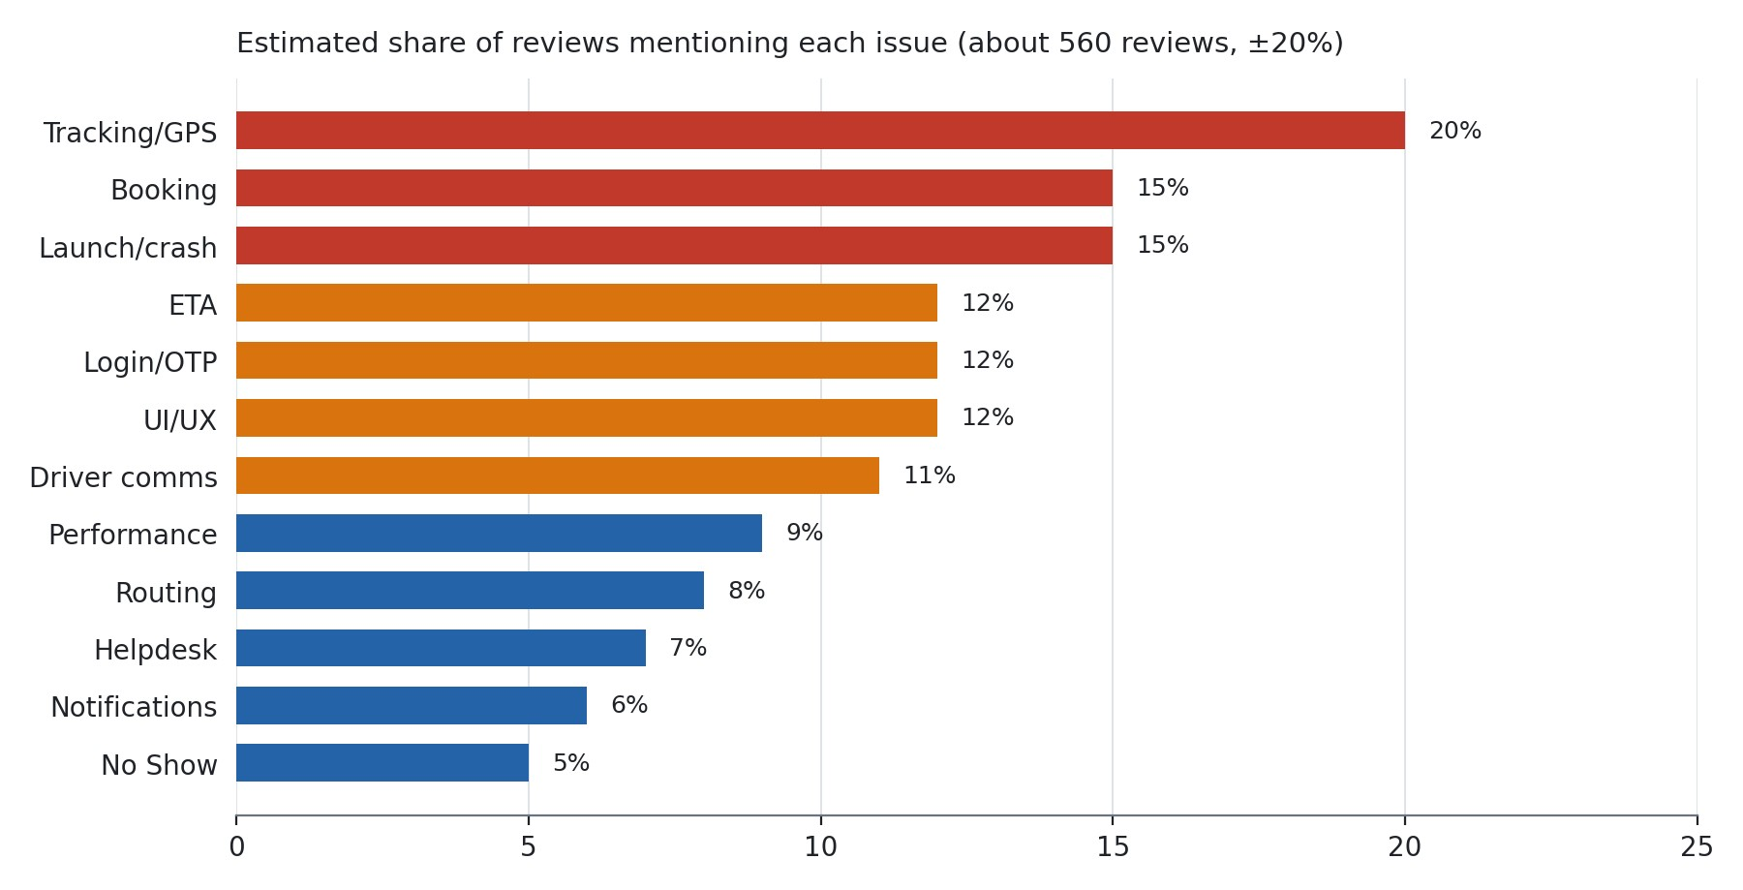
When each problem shows up. This is a rough read of how heavily each issue appears in each period, not a count.
Issue | 2018-19 | 2020-23 | 2024-25 | 2026 (Apr-Sep)
Tracking / stale location | High | Medium | Medium | High
ETA wrong or jumping | High | Medium | Medium | High
Map auto zoom-out | Medium | · | Medium | Low
App will not open / blank | Low | Medium | High | High
"Not installed from Play Store" | · | Low | · | High
OTP not delivered | Low | Medium | Medium | High
Forced re-login | · | Low | High | Medium
Call driver fails / no chat | High | Medium | Medium | Medium
Co-passenger list missing | High | Medium | Low | Medium
Forced or duplicate feedback | · | Medium | Medium | Low
Notification overload | Low | Low | Medium | High
Booking failures | Medium | Medium | Medium | High
No Show disputes | Low | Low | Medium | Medium
Mandatory permissions | Low | · | Medium | Medium
Tracking, ETA and driver communication are the problems that never went away: the same complaints across seven years. Launch failures, OTP and notification overload are rising in 2026. The long-running ones put a ceiling on the rating, and the new ones drag down the current rating.

7. Sentiment analysis

Sentiment is judged from the review text, since star values were not in the captured data.
Sentiment | Share  (estimate) | What it sounds like
Positive | about 22% | "easy to use", "real time tracking is the USP", "SOS within seconds", "no ads"
Neutral or mixed | about 13% | "good app, but..." followed by one specific request (dark mode, QR shortcut, check-in reminder)
Negative | about 65% | reliability, trust, and being ignored
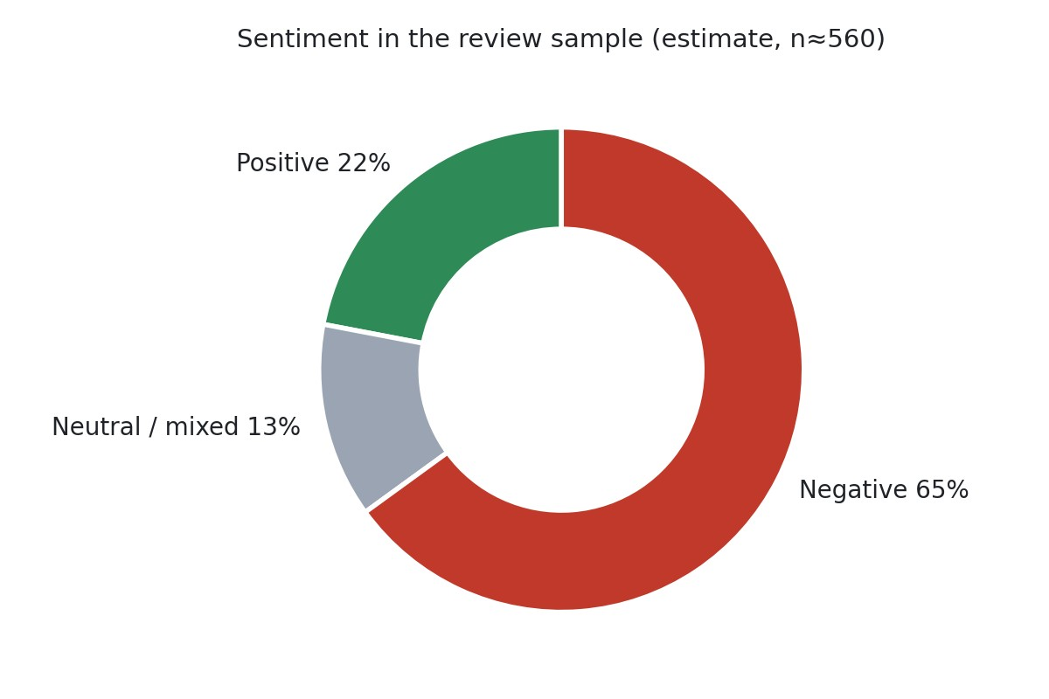
Overall the mood is negative, but the anger is about reliability and about nobody answering, not about the concept. Many angry reviews also say "otherwise a good app". The suggestions are specific and repeat across years (driver chat, a check-in reminder, remember my login, show co-passengers, a self "not travelling" button), which is unusually useful free product research. And positive and negative tracking reviews sit side by side, which is why I would look at what differs between the two groups before changing anything.

8. Root cause analysis

These are hypotheses from reading the reviews. Each needs confirming against logs, Android vitals and release history, which I did not have.
Problem | Likely cause | Evidence | What I would do | Benefit
App says "not installed from Play Store", blank screen | An installer or integrity check misfiring after auto-update, a signing or split-APK problem, or a bad version rolled out to everyone | About a dozen reviews Jun to Sep 2026; Ayan Bhattacharya; the 2023 rooted-device false positive | Pull vitals by version, OS and device; log what the check returns; fail open to a limited mode instead of blocking; staged rollout with auto-halt | People can open the app
Problem | Likely cause | Evidence | What I would do | Benefit
OTP never arrives | One SMS or WhatsApp  provider, no fallback or delivery receipts, operator filtering | Reports across all three channels; a user who needed 50 tries; one user saved by WhatsApp | Fallback across channels with receipts, per-operator dashboards, a clear "number not registered" message | Login works first time
Forced logout | Short token lifetime, tokens dropped on update or background, OTP asked on every open | Rayan, Kalyan, Pranay (logged out within 10 minutes) | Remember the trusted device, re-check with fingerprint or PIN, show a no-login trip card with cab, OTP, driver and SOS | Details and SOS always reachable
Frozen cab icon, old location | Driver phone GPS throttled or killed by battery saver, weak driver devices, stale position shown as live | Garima (30 min),  SWASTIK (1 to 2 hours) | Flag stale positions on the server, show "updated X sec ago", warn operations when pings stop, score GPS quality per vendor | People know when to trust the map
Map zooms out again and again | Camera re-fits pickup, destination and cab on every update | Reported 2019, 2024,  2025, 2026 | Fit once, then respect the user's gestures; add a recenter button | Cheap fix for a longrunning  irritant
ETA jumps | ETA measured to the destination or from a stale position; no traffic or waiting model | Manasa H, John Smith,  Prakhar Verma | ETA to the user's pickup as a range with its freshness; hold back small changes; alert when pickup moves over 10 minutes | Fewer missed cabs
Bookings vanish, duplicate or change date | Booking not confirmed end to end, list not refreshed from the server, date defaulting, load when rosters  open | Nontsikelelo, Pratyusha,  Rahul menon, Joem LZD | Confirmation receipt, idempotency keys, refresh on foreground, a waiting queue at roster open, no auto-advancing dates | Trust in bookings
False No Show | No Show depends on the driver's action alone, with no  GPS or call evidence | Devyash, Jay, kanishk aggarwal, komal Agrawal | Require driver GPS at pickup, a waiting timer and a logged call before No Show; one-tap dispute | Fairness
Slow start | Splash, banners and policy screens sit before the trip card; no cached trip | 10 to 20 second loads; Ankit Rathi; policy pop-up complaints | Show the cached trip first; policy accepted once per version; banners after | Cab details in seconds
"No network" on a good connection | Timeouts shown as offline; ISP, DNS or certificate handling | Wi-Fi-only or data-only failures 2022 to 2026 | Separate offline from server errors; test on major Indian  ISPs; retry with fallback | Works anywhere
Too many  notifications | Reminders fire per event with no de-duplication | "Cancel login" ten times a day; delay pop-ups | De-duplicate per trip and type; cap per hour; one live notification per trip | Alerts people believe

9. Priority matrix

Priority comes first from whether the issue blocks the core journey or affects safety, then from frequency and from impact against effort. Effort sizes are my estimates.
ID | Recommendation | Priority | Impact | Effort | Quadrant
R1 | Fix launch and installer-error failures | P0 | High | M | High impact, medium effort
R2 | OTP delivery and fallback | P0 | High | M | High impact, medium effort
R3 | Remembered session and no-login trip card with SOS | P0 | High | M to L | High impact, high effort
R4 | Tracking freshness label and stop auto-zoom | P1 | High | S to M | High impact, low effort
R5 | ETA stabilisation and pickup-change alerts | P1 | High | M to L | High impact, high effort
ID | Recommendation | Priority | Impact | Effort | Quadrant
R6 | Fair No Show (evidence, call first, dispute, self-mark) | P1 | High | M | High impact, medium effort
R7 | Booking reliability and multi-date | P1 | High | M to L | High impact, high effort
R8 | Driver quick messages | P1 | High | M | High impact, medium effort
R9 | Notification clean-up | P1 | Medium | S | High impact, low effort
R10 | Startup path clean-up | P1 | Medium | S | High impact, low effort
R11 | Rating and feedback flow audit | P1 | High | S | High impact, low effort
R12 | Network and offline resilience | P1 | Medium | M | Medium
R13 | In-app ticket with status and a reply SLA | P1 | Medium | M | Medium
R14 | Co-passenger information defaults | P2 | Medium | S to M | Medium
R15 | Release safety (staged rollout, flags) | P1 | High | M | Enabler
R16 | Routing outlier flags for customers | P2 | Medium | M | Medium
R17 | Fewer permissions | P2 | Low | S | Low impact, low effort
R18 | Dark mode, QR shortcut, larger time font | P3 | Low | S | Low impact, low effort

10. Product recommendations

Each item says what is wrong, what I would change and how I would build it. "Rating effect" is a direction, not a forecast.
R1. Treat the launch failure as an incident (P0, effort M, rating effect: high). People currently hit an error or blank screen at the moment of pickup. Pull Android vitals by version, OS and device this week, reproduce on Android 14, 15 and 17 and on OnePlus and Pixel, and review the installer, integrity and root checks, signing and bundle setup. Log what the check returns. If a check fails, let the user into a limited mode (trip card and SOS) instead of blocking them. Roll out new versions in stages with an automatic halt.
R2. Make OTP delivery reliable (P0, effort M, high). Send by SMS first and fall back to WhatsApp and then email if no delivery receipt arrives within a set time. Add resend with a cool-down, peroperator delivery dashboards, auto-fill using Android's SMS APIs, and honest messages ("number not registered" versus "delivery delayed"). Test the OTP screen on Android 14 and later.
R3. Keep people signed in and always show the trip (P0, effort M to L, high). Use device-bound refresh tokens and re-check with fingerprint or PIN, with a per-customer session length so customers who require two-factor can still comply. I assume a fingerprint check on a trusted device is acceptable to them, which needs confirming with their security teams. Show a trip card without login (cab number, OTP, driver, SOS), cached on the phone. SOS should never sit behind a login.
R4. Make tracking honest (P1, effort S to M, high). Show "updated 12 sec ago" and grey out the cab when the position is old (I would start at about 60 seconds, to be tuned). Frame the map once, then leave the user's zoom alone, with a recenter button. On the server, alert operations when a driver's pings stop, and score GPS quality per vendor and device. This fixes a defect users have reported since 2019.
R5. Stabilise ETA and pickup time (P1, effort M to L, high). Compute the ETA to the user's pickup, using live position, stops remaining and waiting time, and show a range with its age. Hold back changes that are small, and send one alert if the pickup moves by more than 10 minutes. Backtest predicted against actual arrival per customer and shift, and later replace the rules with a trained model (section 11).
R6. Make No Show fair (P1, effort M, medium to high). Require the driver's GPS to be near the pickup, a waiting timer and a logged call attempt before a No Show can be set. For night pickups and women employees, require a call first (as a customer policy option). Let the employee see the evidence and dispute with one tap, and add an "I'm not travelling" button. This answers the most emotional reviews and reduces escalations for customers' transport desks.
R7. Fix booking reliability and hybrid scheduling (P1, effort M to L, high). Show a confirmation receipt after every booking and refresh the list from the server whenever the app returns to the front. Remove the date that jumps ahead. Offer weekday presets such as Monday, Wednesday and Friday for the month where policy allows. Let waitlisted users cancel and rebook before the cut-off. Use idempotency keys and a waiting queue at roster open, and explain each customer's cut-off rules in plain words.
R8. Add quick messages to the driver (P1, effort M, medium to high). Offer tap-to-send messages in both directions ("I'm at gate 3", "wait 2 minutes", "basement, pillar B4"), with a masked call as backup. It needs no microphone permission and the messages can serve as evidence for R6.
This is the most-requested feature across the years in the sample.
R9. Clean up notifications (P1, effort S, medium). One live notification per trip, de-duplicated and capped per hour, no full-screen pop-ups during the critical flow, and a preferences screen. Add the "check in now" reminder that Arvind Kumar suggested for when the vehicle passes your pickup point.
R10. Clean up the startup path (P1, effort S, medium). Ask for the transport policy once per version, show banners only after the trip card has loaded and never full screen, and show the last known trip immediately from cache.
R11. Audit the rating and feedback flow (P1, effort S, medium). First verify the claim that only 4 and 5 stars are offered. Make trip feedback skippable and asked once. Keep private feedback separate from the Play Store prompt, and use Google's in-app review prompt only after a run of good trips and never based on a sentiment filter. Be aware that an honest flow may lower the short-term average before the reliability fixes take effect. That is the price of a rating people believe.
R12. Make the app work with poor network (P1, effort M, medium). Cache today's trip details so they show with no signal, show the last known position with its age, and treat "offline" differently from "server not reachable". Test on the main Indian mobile networks.
R13. Close the support loop (P1, effort M, medium). An in-app "raise an issue" with a status (received, assigned, resolved), a callback option, and a target for replying to Play Store reviews. Stop pointing users to the transport manager when the problem is in the app.
R14 to R18 (P2 and P3). Show co-passengers by initials, area and pickup order where the customer allows it, and a clear message where they have turned it off (R14). Add release safety: stages of 1%, 5%, 20%, 100% with automatic halt, and feature flags for redesigns (R15). Show per-trip detour and pickup-spacing measures to customers (R16). Ask for location only when needed, drop microphone if unused, and remove the forced time-zone setting (R17). Add dark mode, a QR scanner shortcut, a larger time font and a colour-coded calendar (R18).

11. AI recommendations

I would use AI where it removes manual work or improves a decision that fixed rules cannot. The first two are the cheapest and give the most.
Feature | What it does | How | Why it matters
Review analyser | Tags each new review with category, sentiment, owner and severity; groups unfamiliar themes; drafts replies | A language model returning structured output, plus text embeddings; prompts versioned; humans approve replies | Replaces the manual reading I did for this report
Issue detection | Spots a jump in a complaint by app version, Android version or device and links it to vitals | Weekly counts, a simple statistical test, joined with review metadata and Android vitals | Would catch something like the "not installed" cluster within days
Ticket classifier | Routes helpdesk tickets and in-app issues to the right team | The same taxonomy as reviews | One consistent view across channels
Support assistant | Answers questions about cut-offs, why a pickup moved, No Show status | Retrieval over each customer's rules and the person's own trip events, strictly  grounded | Cuts helpdesk load and the  "nobody replies" reviews
ETA  prediction | Predicts arrival at the user's pickup, with uncertainty | Gradient boosting on past trip data (time, route, stops, waiting, vendor, weather), judged on error against today's ETA | Fewer missed cabs, enables "leave now" nudges
Route quality checks | Flags unusual detours and badly spaced pickups before the day | Detour ratio against the direct trip, spacing between same-place pickups | Gives customers evidence to tune policy
Driver quality score | Scores punctuality, GPS health, call attempts before No Show, complaints | Aggregated trip events | Targets operations action; needs human review to stay fair (section 15)
Ratings dashboard | Answers "how are our ratings?" | Output of the above | One place for leadership
I deliberately do not propose AI route optimisation. I know nothing about the current engine, so I would measure routes first (the route quality checks) before suggesting any change.
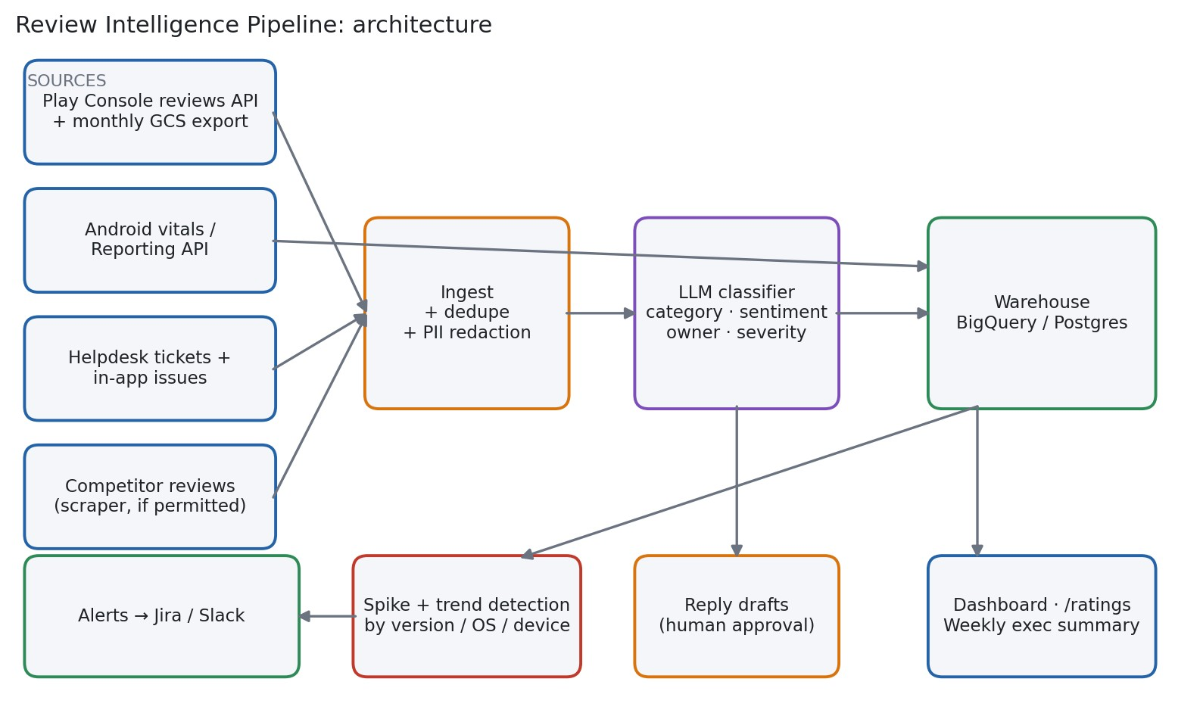

12. Automation solution

The goal is that anyone can ask "how are our Play Store ratings?" at any time and get a current answer without an analyst, and that new problems reach the right team before the rating moves.
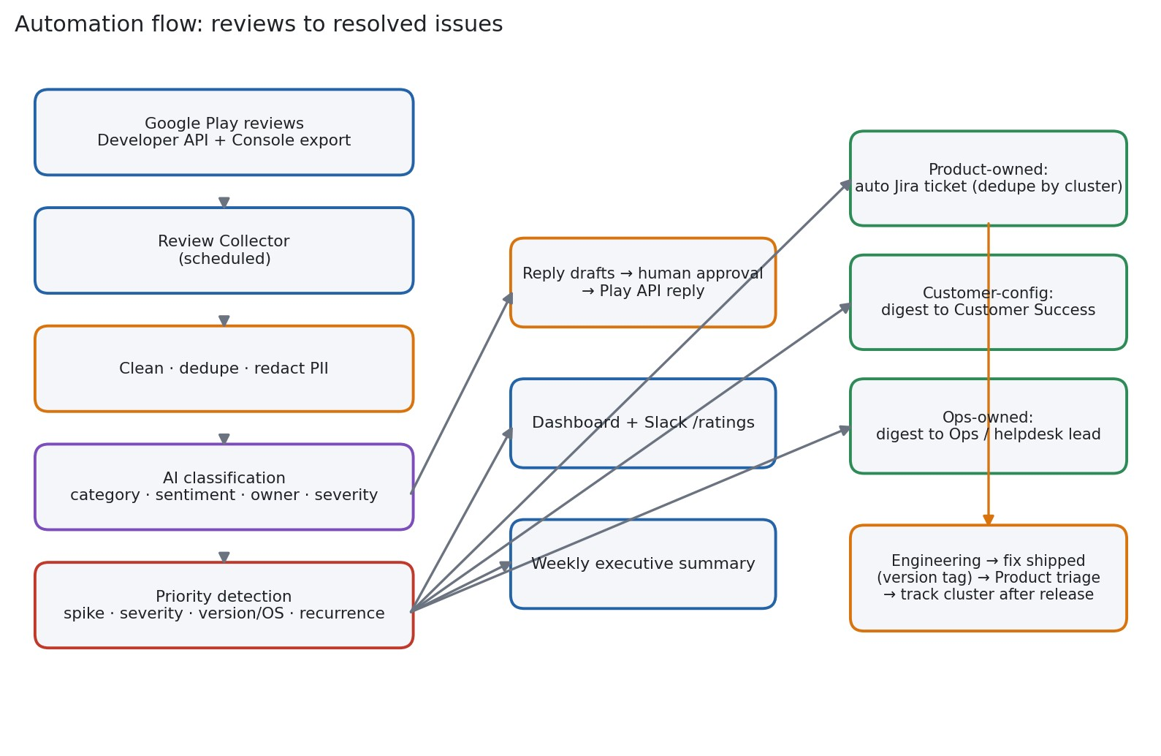
How it works.
- A scheduled job collects new reviews from the Google Play Developer API (which returns the app version, Android version and device with each review) and loads history from the Play Console's monthly export. Crash and ANR rates come from the Play Developer Reporting API.
- Names, phone numbers and employee IDs are removed before any text goes to a language model.
- The model tags each review with the taxonomy in the appendix: category, sentiment, owner (product, customer-configured, operations) and severity. Results are cached by review ID and prompt version.
- A priority step compares this week's volume with the last four weeks, checks whether the cluster is tied to a version, OS or device, and notes whether the same problem existed in earlier quarters.
- Product-owned clusters over a threshold create a Jira ticket automatically, de-duplicated by cluster ID, with the evidence attached (review count, version, OS, three example reviews). Customerconfigured clusters go to a Customer Success digest. Operations-owned clusters go to the operations lead.
- A dashboard, a /ratings 30d Slack command and a Monday summary report the rolling rating, onestar share, top movers and open tickets.
- Draft replies are written in a house style and posted only after a person approves them.
Tech stack. Cloud Scheduler and Cloud Run (or Airflow or GitHub Actions if the team prefers),
BigQuery or Postgres for storage, a language model with a JSON schema for classification, Jira and Slack APIs, Looker Studio or Metabase for the dashboard. A public-listing scraper such as googleplay-scraper could add competitor benchmarks, subject to the terms of service.
Weekly summary contents. Rolling 30 and 90 day average and one-star share against the previous period; top five complaint clusters with owner and ticket link; clusters not seen in the last eight weeks; ratings and crash rate by app version released; reply coverage and median reply time.
Why it holds up. It uses the same classification for the Android and driver apps and could be pointed at other MoveInSync products. Cost grows slowly because each review is classified once. I am assuming a few hundred new reviews a week, which the team should confirm. It can also give percustomer health, since reviews often name employers, but employer names are not a structured field, so that part would be best effort. For quality control, a person audits about 50 labels a week, and anything below a confidence threshold goes to a human.
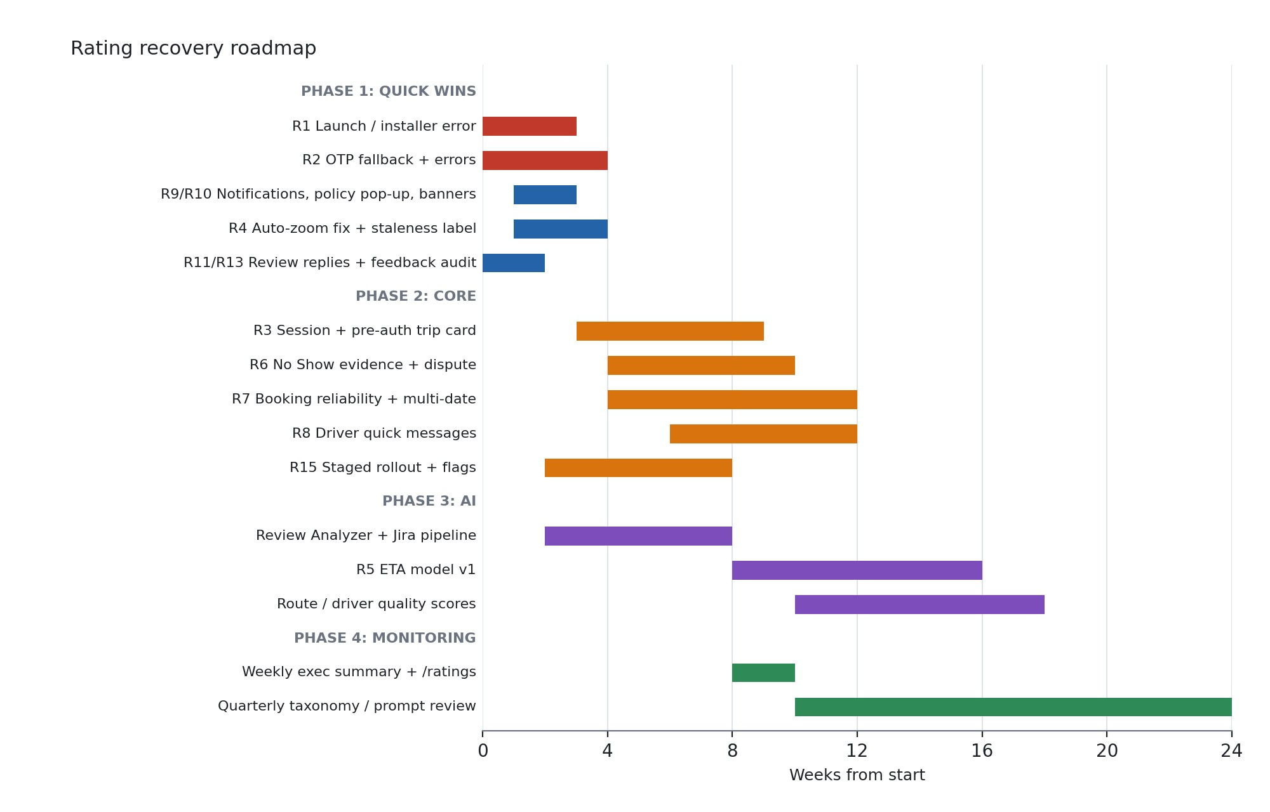
13
. Engineering roadmap
Phase | Weeks | Scope | Done when
1. Quick wins | 0 to 4 | R1, R2, the label and zoom fix in R4, R9, R10,  R11, replies to reviews, baseline measurement | Launch-failure reviews back to normal; login success measured and rising; replies going out
2. Core improvements | 3 to 12 | R3, R6, R7, R8, R12, R13, R15 | No Show disputes and booking-failure reviews falling; staged rollouts are standard
3. AI features | 2 to 18 | Review pipeline (starts early, since everything else uses it), ETA model, route and driver quality scores | ETA error better than baseline; a problem flagged before the rating moves
4. Continuous monitoring | 8 onwards | Weekly summary, /ratings, a quarterly look at the taxonomy | The rating review is a standing meeting
The review pipeline starts in phase 1 because it only needs data access and it gives the team the baseline that shows whether the other work helped.

14. Success metrics

I do not know the current baselines, so week zero is for measuring them. The targets below are proposals, not claims.
Metric | How it is defined | Source | Proposed target
Rolling 30 and 90 day rating | Average of new ratings | Play Console | Rising; report both
One-star share (30 days) | One-star reviews divided by all new reviews | Play Console | Falling for three months in a row
Crash-free users and ANR | Android vitals | Play Developer  Reporting API | Under Google's "bad behaviour" levels (about  1.09% crash, 0.47% ANR; check current values)
Time to show the trip card | p50 and p90 from app start | App telemetry | Set from baseline
Login success on first attempt | Successful over attempts | Backend | 98% or more (proposal)
OTP delivered within 30 seconds | By channel and operator | Provider receipts | 97% or more (proposal)
Booking success | Confirmed over attempted | Backend | 99% or more (proposal)
GPS freshness | Share of trip minutes with a position under 30 seconds old | Backend | 95% or more (proposal)
ETA error | Mean error of ETA 15 minutes ahead against actual arrival | Backend | Improves with each model version
Wrongful No Show rate | Disputes upheld over No Shows | Dispute queue | Falling
Review reply rate and time | Replies to 1 to 3 star reviews; hours to reply | Play API | Every 1 to 3 star review within 3 working days  (proposal)
Support tickets per  1,000 trips | Tickets over trips | Helpdesk | Falling
Retention | Weekly and monthly active use | Product analytics | Stable or rising
The arithmetic behind my earlier caution: if the current average is 4.6 over about 115,000 ratings and new ratings average 4.9, then (4.6 × 115,000 + 4.9 × N) ÷ (115,000 + N) = 4.7 gives N = 57,500.
The lifetime average is slow, so the rolling figure is the one to run the work by.

15. Risks, assumptions and limits

Risks.
- An honest rating prompt may lower the average in the short term. Leadership should hear that in advance.
- Many "bugs" are customer settings (cut-off times, OTP frequency, passenger list, calling). Some fixes need the customer's approval, and the app has to explain the setting to the user.
- Remembered sessions and cached OTPs need review against customer security policies. Changes to SOS and masked calls need a safety sign-off.
- GPS and call quality depend partly on driver phones and vendors, which app changes cannot fully fix.
- A wrong review label does little harm. A wrong driver score does, so scores need human review.
- Reviews contain names and employers. Remove them before processing and never publish perperson data.
- Replies and prompts must follow Play policy, and scraping competitors must respect the terms of service.
Assumptions. The sample leans negative; effort sizes assume a small team; Play shows a rating that weighs recent ratings more (to verify); a few hundred new reviews arrive each week; a fingerprint on a trusted device is acceptable as the second factor.
Limits. No per-review star value or star histogram; no crash logs, backend logs, release notes or customer settings, so root causes are hypotheses; counts are hand-coded and approximate; one store snapshot; the iOS app and the driver app were not analysed; some reviews describe the vendor or employer rather than the app.

16. Final recommendations: ten things to start now

- Open an incident for the "not installed from Play Store" and blank-screen failures, pull vitals by version and OS, and ship a hotfix that fails open.
- Fix OTP delivery with fallback across channels, receipts per operator and honest error messages.
- Stop forced logouts from blocking safety: remembered device, a no-login trip card, SOS always reachable.
- Make tracking honest: show how old the location is, fix the auto zoom-out that has been open since 2019, add a recenter button.
- Stabilise ETA and send one alert when pickup time moves by more than 10 minutes.
- Reform No Show with GPS and call evidence, a call first at night, a dispute button and an "I'm not travelling" button.
- Remove interruptions: de-duplicate and cap notifications, ask for the policy once per version, no full-screen banners before the trip card.
- Verify the 4 and 5 star claim, make feedback skippable and asked once, and fix how the Play Store prompt is used.
- Ship quick messages to the driver, with a masked call as backup and no microphone permission.
- Build the review pipeline and a reply target, and stop answering app bugs with "ask your transport manager".

17. Appendix

A. Review examples
Theme | Reviewer and date | Short excerpt
Installer error | Govindaraj K, 30 Jul 2026 | error that the app was not installed through the Play Store
Update breaks launch | Ayan Bhattacharya, 10 Aug 2026 | works until it auto-updates, then will not launch
OTP | Goli Nagamalleswararao, 22 Apr 2026 | tried nearly 50 times, no OTP
Forced logout and safety | Rayan D'Souza, 13 May 2026 | logged out every 5 to 10 minutes; blocks SOS
Stale location | SWASTIK TRIPATHI, 10 Aug 2026 | location shown as one or two hours ago
ETA | John Smith, 13 Jun 2026 | app says an hour, driver arrives in five minutes
No Show | Devyash Pundir, 21 Jul 2026 | waited over two hours for the cab, then marked No Show
Booking | Nontsikelelo Candice, 18 Jun 2026 | chosen dates differ from the bookings created
Notifications | Prateek Goyal, 16 Sep 2026 | delay pop-ups every few minutes
Pop-ups and SOS | Swapnil Deore, 9 Sep 2026 | pop-ups get in the way of using SOS
Microphone | kanchan kumar, 3 Aug 2026 | microphone forced with no in-app calling
Rating system | Ranveer Mendigire, 16 Jul 2026 | says only 4 or 5 stars can be selected
Theme | Reviewer and date | Short excerpt
Zoom bug | Vinayak Phal, 7 Nov 2025 | developer reply promises better tracking
Chat request | Abhishek Chaudhary, 1 Jun 2022 | asks for chat; 221 helpful votes
Offline | Sailesh Sunkara, 12 Jan 2026 | lost OTP and driver details when signal dropped

B. What each complaint should be measured by
What users say | What to instrument
"keeps loading", "blank" | start-up time, first-render failures, API p95
"not installed" | integrity result, install source, version, OS
"OTP not received" | sent, delivered, entered, by channel and operator
"location stuck" | seconds since last position, per trip
"ETA wrong" | predicted against actual arrival at 15 and 5 minutes before
"marked No Show" | driver distance from pickup, waiting time, calls attempted
"booking missing" | app list against server list when the app returns to the front

C. Classifier taxonomy (version 1)
Categories: launch_crash, login_otp, tracking_gps, eta, booking, driver_comm, notifications, performance, ui_ux, routing, support, no_show, feedback_flow, permissions, safety, network, copassenger, other. Each review also gets a sentiment (positive, mixed, negative), an owner (product, customer_config, operations) and a severity from 1 to 5.

D. Guidance for replying to reviews
Name the specific problem in a sentence, not a generic apology. For product bugs, say what is being done and give a version or timing when known. For customer-set rules, say which setting it is, who can change it and whether MoveInSync can raise it with the customer. Ask for details such as app version once, and in a private channel. Never imply the reviewer is at fault.

E. Reference sketch of the pipeline (not tested)
fetch_reviews() # Play Developer API reviews.list or the monthly Console export redact(text) # remove names, phone numbers, employee IDs
classify(text) # LLM with a JSON schema; cache by hash of text + prompt version weekly_summary(rows) # rolling 30-day average, one-star share, top 5 categories maybe_open_jira(c) # only for product-owned clusters above the threshold

